Butler Takes a Step Forward
In Preserving the Past

The City of Butler is now a preservation partner with local, state and national governments as the latest member of the Certified Local Government Program (CLG). This program promotes historic preservation at the grass roots level and is jointly administered by the National Park Service and the Missouri State Historic Preservation office.

CLG cities have the advantage of receiving technical training on a variety of preservation topics and have priority status for historic preservation grants. A special set of funding priorities are determined each year and may include preparation of nominations for local districts and landmarks: design guidelines; professional staff assistance; long-range comprehensive preservation planning projects; and outreach and education projects. Butler is now an active partner in the Federal Historic Preservation Program and al the opportunities it provides.

As part of the CLG program, a Butler Historic Preservation Commission has been established. The five member Commission has been working over the past year, as part of the CLG program application process, the identify preservation needs and ways of addressing them in Butler. A facebook page will be set up to provide timely information on Commission activities and to encourage community participation in preserving Butler’s history.

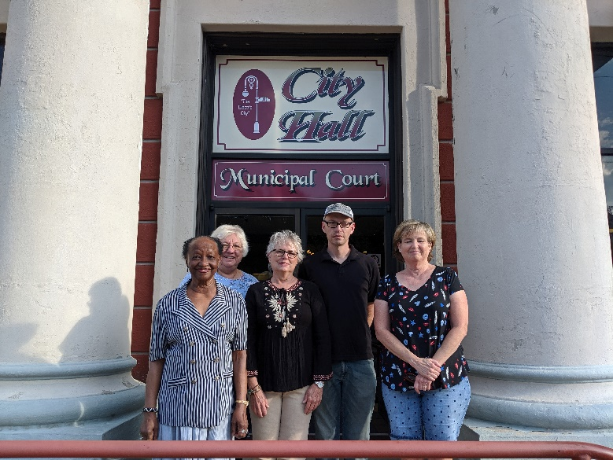
The Butler HPC is seeking old photographs, advertising materials, oral histories and old maps of Butler. Houses and business buildings with significant architectural or historical events/people will be designed local historical landmarks, help will be provided with applications for property listing on the National Register of Historic Places, installation of signage directing visitors to area museums and painting of murals are among the activities planned by the Commission. Volunteers are needed to assist in carrying out these activities.

There will be a special program on qualifying for the National Register of Historic Places on January 23. For more information, to volunteer or to share historical documents, contact City Hall or email: butlermohistory@gmail.com.

Members are: Patricia Jacobs, Melissa Phillips, Doris Fuller, Chris Wimsatt, Carolyn Jett

Notice of Historic Preservation Program
January 23, 2020

The Butler Historic Preservation Commission will host a program on Working on National Register of Historic Places and local Historic Landmark designations. The program will be held on January 23, at 6:00 pm at the Caskey Mediation Room on the west side of the Butler Square.

The program will cover the requirements and application procedure for listing on the National Register of Historic Places. It will also explain the new local Historic Landmark designations available for residential and commercial properties in Butler.

Plans also include a second program in late April with a staff member for the State Historic Preservation Office who will visit properties identified in this January meeting and provide more detailed information on the application process, restoration tax credits and grant availability.

